Freezing Time and Slicing Space: The Spatiotemporal Revolution of Ultrafast Lasers in Biological Imaging

陈信均 12311125
何衍宁 12311512

Abstract：Traditional biological imaging techniques are fundamentally limited by the slow response times of electronic detectors and a heavy reliance on radiative fluorescence. This leaves critical non-fluorescent molecules invisible and rapid dynamic processes irreversibly blurred. This article explores the spatiotemporal revolution catalyzed by ultrafast lasers in biomedical diagnostics. We demonstrate how the extreme brevity of the pulse serves as a precise optical gate, decoupling temporal resolution from electronic bandwidths. This capability empowers Pump-Probe microscopy to capture the transient non-radiative heat dissipation of molecules such as melanin, enabling non-invasive "optical biopsies" for melanoma detection. Simultaneously, the inherently broad spectral bandwidth of these ultrashort pulses provides a minimal spatial coherence length. This allows Optical Coherence Tomography (OCT) to completely decouple depth resolution from the lens's numerical aperture, achieving sub-micrometer, three-dimensional anatomical cross-sections. Ultimately, the integration of these ultrafast physical properties not only breaks the limits of traditional optics but also establishes a robust foundation for next-generation, label-free imaging modalities like Stimulated Raman Scattering (SRS).

Keyword: Ultrafast Laser; Biological Imaging; Spatiotemporal Resolution; Pump-Probe Microscopy; Optical Coherence Tomography (OCT).

  - The Principle of Ultrafast Laser
To truly appreciate the transformative capabilities of ultrafast lasers in biological imaging, we must first examine the physical mechanism of their generation. Inside a standard continuous-wave (CW) laser cavity, countless different frequencies of light—known as longitudinal modes—oscillate simultaneously. The total electric field $E\left(t\right)$ can be described as a superposition of these N modes:
$E\left(t\right)=\sum_{n=-N/2}^{N/2}{E_{0}}*exp\left[i\left(ω_{0}+nΔω\right)t+ϕ_{n}\right]$ (1)
where $ω_{0}$ is the central angular frequency, $Δω$ is the mode spacing, and $ϕ_{n}$ is the phase of the n-th mode. In a CW laser, the phase $ϕ_{n}$ is random. Because the modes are temporally out of sync, their electromagnetic fields average out over time, resulting in a continuous, uniform intensity $I\left(t\right)$.
An ultrafast laser fundamentally alters this dynamic through mode-locking. This mechanism forces a fixed phase relationship across all individual frequencies.[1] Under this strict phase-locking condition, the modes constructively interfere. The resulting intensity $I\left(t\right)∝{\left|E\left(t\right)\right|}^{2}$ becomes:
$I\left(t\right)∝{\left|E_{0}\right|}^{2}∝\frac{sin^{2}\left(NΔωt/2\right)}{sin^{2}\left(Δωt/2\right)}$ (2)
This mathematical superposition produces an incredibly intense, localized burst of electromagnetic energy. The defining characteristic of these lasers is their extremely short pulse duration, typically ranging from picoseconds (${10}^{-12}$s) down to femtoseconds (${10}^{-15}$ s).

1.2 The Origin of Temporal Resolution
This extreme brevity is the fundamental source of the ultrafast laser's unparalleled temporal resolution. The physics of these ultrashort pulses is strictly governed by the time-frequency Fourier transform limit, analogous to Heisenberg's uncertainty principle. For a transform-limited pulse, the temporal duration ($Δt$) and the spectral bandwidth ($Δν$) must satisfy:
$Δt ⋅Δν ≥K$ (3)
where $K$ is a constant depending on the pulse shape (e.g.,$K is about 0.44$1 for a Gaussian pulse). To achieve a minimal $Δt$ on the femtosecond scale, the laser system must emit light across a massive range of optical frequencies.
In optical imaging, this ultrashort $Δt$ serves as a precise temporal gate. Standard electronic detectors operate in the nanosecond (${10}^{-9}$ s) regime, rendering them too slow to resolve the transient intermediate states of molecular systems (such as non-radiative energy dissipation occurring in picoseconds). However, by utilizing ultrafast pulses, the temporal resolution is no longer dictated by the electronic bandwidth, but rather by the optical pulse width $Δt$itself, allowing researchers to map dynamic cellular pathways with absolute temporal clarity.

1.3 The Origin of Spatial Resolution
Beyond conquering the temporal domain, the fundamental physics of ultrafast lasers simultaneously endows them with unprecedented spatial resolution capabilities.
As dictated by the Fourier limit which we mentioned in equation (3) [2], generating an ultrashort pulse inherently requires an exceptionally broad spectral bandwidth ($Δλ$). In optical physics, a broad spectrum is fundamentally tied to a short coherence length. When light undergoes interference, the spatial region over which interference fringes can be written as:
$Δz=\frac{2ln2}{π}\frac{λ_{0}^{2}}{Δλ}$ (4)
where $Δz$ is the depth resolution. $λ_{0}$ is the central wavelength. It is evident from the equation that a vast spectral bandwidth translates directly into a minimal $Δz$. This allows the optical system to pinpoint backscattered signals with exceptional precision, enabling researchers to resolve microscopic anatomical layers with sub-micrometer depth resolution [3].
2. The Ultimate in Temporal Resolution—Pump-Probe Imaging
Having established that ultrafast lasers serve as perfect, impulse-like optical samplers, we now turn to how this capability is engineered into a functional imaging system. The most profound realization of this temporal resolution is Pump-Probe imaging, a technique that effectively measures time using light, allowing us to visualize the "invisible" dynamics of biological molecules.

2.1 The Mechanism of Pump-Probe
At its physical core, Pump-Probe microscopy utilizes two synchronized ultrafast laser pulses to generate and observe transient molecular states. This process can be conceptualized as microscopic, high-speed photography session where the two pulses play distinctly different roles:
The Pump Pulse: The first intense femtosecond pulse strikes the biological sample. It acts as the initiator, transferring energy to the target molecules (such as melanin) and abruptly exciting a fraction of their electron population from the ground state to a higher energy state.
The Probe Pulse: Suddenly, much weaker pulse arrives at the sample after a precisely defined time delay ($Δt$). Its primary function is not to excite, but to simply pass through the sample and "read" the altered molecular state.

Because the Pump pulse temporarily altered the population of electrons in the ground and excited states, the sample's ability to absorb light changes for a brief moment. By measuring the intensity of the transmitted or reflected Probe pulse, the system records the transient absorption change ($ΔA$). If we plot this $ΔA$ over varying delay times, we map the exact trajectory of how the molecule relaxes back to its ground state.

2.2 Engineering Implementation of Pump-Probe
A critical engineering paradox arises here: if our electronic circuits are too slow to resolve femtosecond events, how can we possibly control the time delay ($Δt$) between the Pump and Probe pulses with femtosecond precision?
The elegant solution lies in abandoning electronic timing entirely and turning to the speed of light.
In a Pump-Probe system, the original laser beam is split into two optical paths. The Probe beam is routed through an Optical Delay Line—a pair of mirrors mounted on a highly precise, motorized mechanical translation stage. By moving this stage backward or forward, we physically lengthen or shorten the distance the Probe light must travel before reaching the biological sample.
This simple equation represents a brilliant engineering paradigm shift. Moving a mechanical stage by just 1.5 micrometers, which is a routine task for modern piezoelectric motors, creates a precise optical delay of 10 femtoseconds. We have successfully traded manageable spatial distance for an otherwise impossible temporal resolution, converting a picosecond timing problem into a straightforward spatial positioning problem.

2.3 Typical Biomedical Applications by Pump-Probe imaging
The ability to map transient absorption gives Pump-Probe imaging a unique and highly disruptive advantage in biomedical diagnostics.
The Pain Point in Traditional Diagnostic and Optical Methods: Currently, the clinical gold standard for diagnosing melanoma relies on visual inspection (dermoscopy) followed by an invasive physical biopsy and histopathological staining. However, biopsies are inherently invasive, slow, and subject to sampling errors.
If we attempt to perform a non-invasive "optical biopsy" using traditional optical microscopy, we immediately hit a fundamental photophysical wall. The diagnostic marker for skin cancer lies in the specific distribution and chemical composition of melanin. Biologically, there are two main types of melanin: eumelanin (brown/black pigment, generally protective) and pheomelanin (red/yellow pigment, often associated with oxidative stress and elevated in dysplastic or malignant lesions).
Traditional optical methods fail to differentiate these states for two rigid reasons [4]:

- The Absence of Fluorescence: Standard high-resolution techniques (like confocal fluorescence microscopy) rely on radiative decay. However, melanin has an extraordinarily low fluorescence quantum yield (< ${10}^{-3}$). It dissipates absorbed energy almost entirely through non-radiative pathways (heat). To a fluorescence microscope, melanin is simply a dark, invisible void.
- Featureless Linear Absorption: If we try to use standard bright-field microscopy to measure linear absorption (measuring how much light is blocked), we fail because the linear absorption spectra of eumelanin and pheomelanin are incredibly broad, structureless, and heavily overlapping. Consequently, without functional contrast, these chemically distinct regions are entirely indistinguishable under conventional linear absorption imaging. In this way, traditional linear optics cannot extract the chemical specificity required to distinguish healthy pigment from a malignant molecular environment.

Pump-Probe imaging beautifully bypasses these linear optical limitations by interrogating the non-radiative heat dissipation process itself.[5]
When struck by an ultrafast Pump pulse, the electrons in both eumelanin and pheomelanin are excited. However, because of their different molecular structures, the speed at which they dissipate that energy differs profoundly. Eumelanin typically exhibits a very rapid, mono-exponential energy relaxation, whereas pheomelanin and highly disorganized malignant melanin exhibit a much slower, multi-exponential decay profile.
By sweeping the optical delay line, researchers capture the transient absorption ($ΔA$) signal over time. Rather than relying on a static morphological image, pathologists can mathematically differentiate malignant from benign tissues by analyzing the specific exponential decay constants of these dynamic molecular curves. This enables a true "optical biopsy," mapping the exact boundaries of cancerous tissues with absolute chemical specificity and zero physical incisions.[6]

2.4 The Further Development of Ultrafast Temporal Gating
Building upon this foundational principle of ultrafast temporal gating, this paradigm has catalyzed a new generation of advanced imaging modalities. Most notably, it has paved the way for Stimulated Raman Scattering (SRS) microscopy, which utilizes dual ultrafast pulses to probe specific molecular vibrations for label-free chemical imaging, and Time-resolved Photoacoustic Microscopy (PAM), which cleverly translates ultrafast thermal expansion into ultrasonic waves, successfully breaking the optical diffusion limit for deep-tissue penetration.

3. The Ultimate Spatial Resolution: Optical Coherence Tomography (OCT)
As discussed previously, the inherently broad spectrum of ultrafast light sources not only acts as a precise temporal gate but also provides a robust physical foundation for breaking spatial resolution limits [7]. Pump-Probe technology pushes time resolution to the limit. Optical Coherence Tomography (OCT) uses short coherence lengths for great spatial (depth) resolution. This has caused a true revolution in clinical medicine.

3.1 The Physics of OCT: Using Light Instead of Sound
OCT can be functionally understood as a high-resolution "optical ultrasound". Traditional ultrasound uses sound echoes to measure tissue depth. However, the speed of light c is simply too fast. Normal electronic devices cannot directly record the travel time of light in tiny tissues.
To solve this problem, OCT uses the design of a Michelson Interferometer. The system splits the broadband light beam into two precise paths:
Reference Arm: The light hits a mirror. Its distance is known and can be controlled.
Sample Arm: The light hits the biological tissue. The light scatters back from different layers inside the tissue (like cell membranes).

3.2 The Math of Spatial Resolution: Wider Spectrum, Thinner Slice
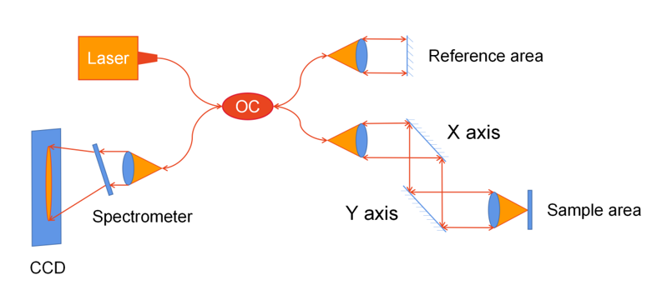

When the two light beams meet, they do not always interfere. The light source has a very wide spectral bandwidth ($Δλ$). Many different light frequencies mix together. This makes its spatial coherence length ($L_{c}$) extremely short [8].
Interference only happens under strict conditions. The optical distance of the sample arm must exactly match the reference arm. The error must fall within the tiny range of $L_{c}$. If we assume the light source has a Gaussian shape, the axial (depth) resolution $Δz$ is limited by the Fourier transform limit, as we mentioned in equation 4.
This formula shows a huge victory in optical engineering. In an OCT system, depth resolution has nothing to do with the lens's numerical aperture (NA). By using a broadband light source with a huge $Δλ$, researchers can keep a deep focus. They can use a short coherence gate to extract signals from a specific depth. This achieves sub-micrometer 3D optical slices.

3.3 Engineering Design: From Mechanical Movement to Math
Early Time-Domain OCT (TD-OCT) used mechanical motors. They moved the mirror in the reference arm very fast. This scanned the sample's depth point by point. However, modern high-resolution OCT systems have moved to Fourier-Domain OCT (FD-OCT). Mechanical movement is completely gone. Instead, the system records the "interference spectrum". Subsequently, a Fourier transform is mathematically applied to extract the depth information instantaneously. Engineers created two different ways to do this:

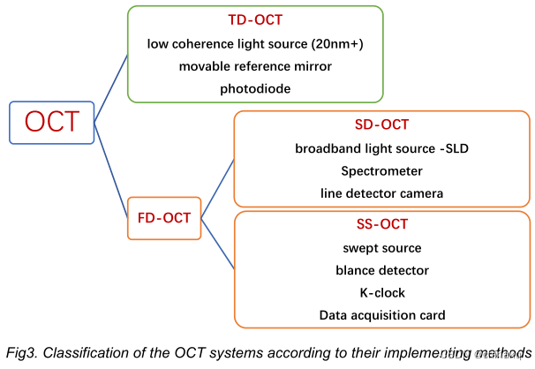

3.3.1 Spectral Domain OCT (SD-OCT): Spreading Light in Space
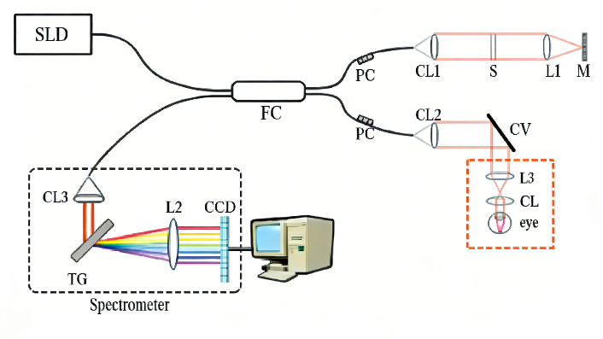
SD-OCT simultaneously illuminates the sample with a broadband source (e.g., an SLD). The backscattered light is subsequently dispersed by a spectrometer and captured by a high-speed camera (CCD/CMOS), allowing a single exposure to record the entire interference spectrum.
SD-OCT has no moving mechanical parts. It is very stable against tiny vibrations. This makes it the main tool for OCT Angiography (OCTA). Also, mature broadband sources make it easy to get extremely high depth resolution.
SD-OCT faces a problem called Sensitivity Roll-off. As the imaging goes deeper, the returning light stripes get too dense. The camera pixels have a physical size. If the stripes exceed the camera's limit, the image contrast drops sharply.
    - Swept-Source OCT (SS-OCT): Scanning Light over Time
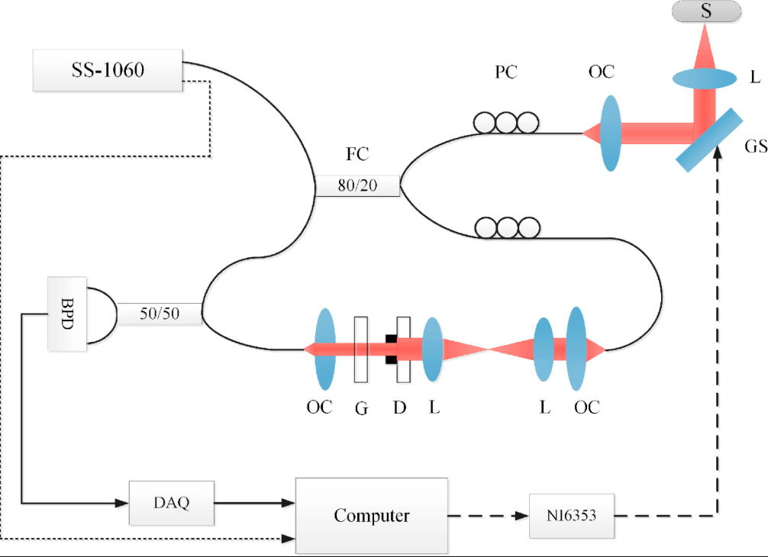
SS-OCT scans single colors over time. It uses a swept-source laser. The laser quickly changes its wavelength (for example, from 1000 nm to 1100 nm in 1 µs). Because different wavelengths are separated by time, it does not need an expensive spectrometer. It only needs one fast balanced photodetector.
The laser line is very narrow. This completely breaks the camera's "roll-off" curse. It keeps high contrast in very deep tissues. Also, longer wavelengths (like 1050 nm or 1310 nm) give it deeper optical penetration. Advanced laser tech also gives it super-fast imaging speed [7].
However, this approach presents significant engineering challenges and high costs, as developing a laser capable of rapid wavelength sweeping while maintaining a narrow linewidth is technically demanding. It usually needs extra optical paths to calibrate the timing.

3.4 Typical Biomedical Applications
Extreme spatial resolution makes OCT irreplaceable in clinics. It upgrades traditional 2D surface observation to true 3D "optical biopsies":
While conventional fundus cameras provide only 2D surface imaging, SD-OCT enables clinicians to acquire non-invasive, high-resolution optical cross-sections of the retina. They get a resolution of a few micrometers. They can clearly see tiny cell layers. This helps them find early signs of diseases like glaucoma. SS-OCT can even easily see through the thick layers at the back of the eye.
Miniaturized OCT catheters can be navigated into blood vessels (IVOCT), providing high-resolution intraluminal scans of the vascular walls. OCT is able to clearly measure tiny dangerous structures. It provides crucial warnings before a fatal heart attack happens.

4. Conclusions
The evolution of ultrafast lasers has driven a profound paradigm shift in biological imaging, moving the field far beyond the physical limitations of traditional optics and sluggish electronic detectors. By mastering the extreme physics of the Fourier transform limit, researchers have successfully transformed optical challenges into unprecedented spatiotemporal advantages.
By harnessing the extreme brevity of femtosecond and picosecond pulses, techniques like Pump-Probe microscopy effectively use light to measure time. This elegant engineering solution trades spatial distance via optical delay lines for temporal precision, allowing scientists to bypass electronic bottlenecks. Consequently, it is now possible to observe the transient, non-radiative heat dissipation of "invisible" molecules like melanin, enabling true, non-invasive optical biopsies for conditions such as melanoma.
Simultaneously, the inherently broad spectral bandwidth required to generate these ultrashort pulses provides the foundation for ultimate spatial resolution. Optical Coherence Tomography (OCT) capitalizes on this broad spectrum and the resulting short spatial coherence length to completely decouple depth resolution from the numerical aperture of the lens. Through sophisticated engineering iterations like Spectral-Domain (SD-OCT) and Swept-Source (SS-OCT), the technology delivers sub-micrometer, 3D anatomical cross-sections that have become irreplaceable in modern ophthalmology and intravascular diagnostics.
Ultimately, the foundational principles of ultrafast temporal gating and low-coherence interferometry have not only revolutionized current clinical practices but have also catalyzed a new generation of advanced modalities. Together, these advancements cement ultrafast laser technology as an indispensable cornerstone of modern, label-free biomedical diagnostics.

References:
[1] H.A. Haus, Mode-locking of lasers, IEEE Journal of Selected Topics in Quantum Electronics 6(6) (2000) 1173-1185.https://doi.org/10.1109/2944.902165
[2] A.H. Zewail, Femtochemistry: Atomic-Scale Dynamics of the Chemical Bond, The Journal of Physical Chemistry A 104(24) (2000) 5660-5694.https://doi.org/10.1021/jp001460h
[3] D. Huang, E.A. Swanson, C.P. Lin, J.S. Schuman, W.G. Stinson, W. Chang, M.R. Hee, T. Flotte, K. Gregory, C.A. Puliafito, J.G. Fujimoto, Optical Coherence Tomography, Science 254(5035) (1991) 1178-1181.https://doi.org/doi:10.1126/science.1957169
[4] I.R. Piletic, T.E. Matthews, W.S. Warren, Probing Near-Infrared Photorelaxation Pathways in Eumelanins and Pheomelanins, The Journal of Physical Chemistry A 114(43) (2010) 11483-11491.https://doi.org/10.1021/jp103608d
[5] W. Min, S. Lu, S. Chong, R. Roy, G.R. Holtom, X.S. Xie, Imaging chromophores with undetectable fluorescence by stimulated emission microscopy, Nature 461(7267) (2009) 1105-1109.https://doi.org/10.1038/nature08438
[6] T.E. Matthews, I.R. Piletic, M.A. Selim, M.J. Simpson, W.S. Warren, Pump-probe imaging differentiates melanoma from melanocytic nevi, Sci Transl Med 3(71) (2011) 71ra15.https://doi.org/10.1126/scitranslmed.3001604
[7] N. Nishizawa, Wideband ultrafast fiber laser sources for OCT and metrology, Journal of Physics B: Atomic, Molecular and Optical Physics 49(18) (2016) 182003.https://doi.org/10.1088/0953-4075/49/18/182003
[8] P. Chen, Z. Long, Q. Cheng, M. Song, W. Wang, R. Liu, Z. Zhang, K. Xia, Z. Yang, L. Qian, S. Bai, X. Wang, P. Yang, P. Xu, E.S. Yousef, R. Wang, On-Chip Supercontinuum Generation Pumped by Short Wavelength Fiber Lasers, Photonics, 2024, p. 440.10.3390/photonics11050440.

